LOCATION : NATIONWIDE
DATE : 12.01.2018
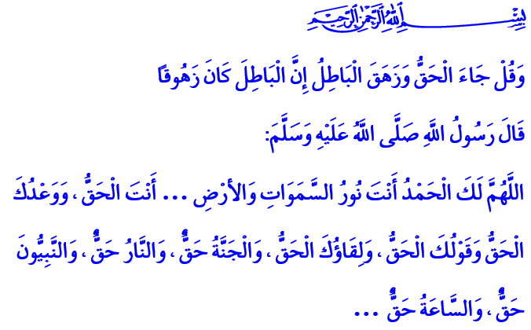TO STAND BY THE TRUTH, AND AGAINST THE FALSEHOOD
Blessed Friday to You, Brothers and Sisters!
Our Prophet (pbuh) conquered Mecca with his army, the city where he had to leave ten years ago with the journey of hegira. The Messenger of Allah was born and grew up in this blessed city and he was longing for it. He looked at the city with longing eyes then he went towards the House of Allah with enthusiasm and excitement. After the tawaf (circumambulation), he went in the Kaaba and cleared it and its surroundings from the idols after he recited this verse: 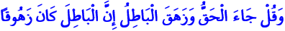 “And say: truth has (now) arrived, and falsehood perished: for falsehood is (by its nature) bound to perish.”
Honorable Believers!
One of the most beautiful names of Allah Almighty is “Al-Haqq” (The Embodiment of Truth). Our Lord is the only source and sole owner of the truth and justice. He invited people to know the truth with His holy prophets, from Adam to Muhammad Mustafa (pbuh.). The battle between truth and falsehood in human history started with the two sons of Adam, Habil and Qabil. While Habil stood by the truth with submission and sincerity, Qabil choose falsehood with his greed and jealousy. To the end of days, Habil will be the leader of the good ones and the goodness, while Qabil will be known as the symbol of evil ones and evil with the murder he committed.
Dear Brothers and Sisters!
The truth is the faith of tawheed. It is the faith in and submission to Allah. It is being a servant only to Him. The falsehood is to deny the existence and oneness of Allah and associate partners with Him. It is to serve others than Him. It is to be a servant to desires and wants. It is to be blind and deaf towards His countless blessings.
The truth is the life giving principles and the beauties of the manifest religion that is Islam which makes us human and the world a place to live. The falsehood is the beliefs and ideas that are incompatible with our supreme religion. It is the practices that wage war on Islam. It is the evil that harms the honor and dignity of the people.
The truth is the Holy Quran, our guide to salvation, which distinguishes between good and evil. It is the irreplaceable example of our Prophet (pbuh.). The falsehood is the behaviors that aim to remove our Holy Book and the holy sunnah of our Prophet from the hearts and the minds.
The path of the truth is the path of the prophets, martyrs, and good and faithful believers. At the end of this road lays a paradise of eternal blessings. The path of falsehood is the path of unbelievers, condemned, those who stray from righteousness, and the evil ones. The end of this road leads to hell that is home to doom and loss.
Brothers and Sisters!
While those who stay on the path of the truth become the hope of the oppressed and the downtrodden; those who unite in falsehood generally become the voice of oppression and the oppressors. While those who set their hearts to the truth fight for high values; those who fell into falsehood hold interests and self-seeking above all. While the lovers of the truth work in order to build the earth and make it livable; the servants of falsehood seek sedition, malice, lies, slander, and mischief. While those who stand by the truth strive to make peace, comfort, and justice prevail on earth; the followers of falsehood try to spill blood and tears, turn cities into ruins, and harm the minds and the hearts.
Brothers and Sisters!
Our Poet of Independence describes a heart that is a lover of truth in these lines, and how meaningful they are:
It cuts me to bone when I see a bleeding wound,
I would get whipped to relieve it, or get kicked!
I can’t say “Never mind, let it go”, I’ll mind.
I’ll trample, get trampled, I’ll raise the truth!
So, brothers and sisters! Whatever the circumstances, let us continue to stand by the truth and against the falsehood, let us continue to be the voice of the truth. Let us not abandon recommending one another the truth and patience. We must not forget that the help and mercy of Allah is going to be with us as long as we keep serving the truth. The falsehood could never hurt us as long as we pick up and raise the truth.
I want to conclude this khutba with this hadith of our Prophet:
“O Allah! All the Praises are for You; You are the Lord of the Heavens and the Earth and whatever is therein. You are the Truth, and Your Promise is the Truth, and Your Speech is the Truth, and meeting You is the Truth, and Paradise is the Truth and Hell (Fire) is the Truth and all the prophets are the Truth and The Final Hour is the Truth.
O Allah! Please forgive my past and future sins and those sins which I did in secret or in public. It is You Whom I worship. There is no God but You.”

Al-Bukhari, Oppressions, 32; Sahih Muslim, Jihad and Expeditions, 87.
Al-Isra,17/81.
Al-Bukhari, Oneness, Uniqueness of Allah (Tawheed), 35. Written by: General Directorate of Religious Services

